Core Concepts
- Azure AD Instance Structure:
Traditionally, an Azure AD tenant contains users, groups, service principals, and applications in a flat structure without hierarchical subdivisions. All users and groups exist on the same level within the tenant.
- Azure AD Roles:
Azure AD includes many built-in roles (e.g., Global Administrator, User Administrator) that grant permissions across the entire tenant. These differ from Azure Resource Manager roles and are primarily used for managing Azure AD and related services like Office 365.
- Limitation of Traditional Role Assignment:
Roles are assigned at the tenant-wide level, meaning a user with a role has permissions across all users and groups in that tenant. There is no native way to restrict a role’s scope to a subset of users or groups.

Introduction to Administrative Units (AUs)
- Purpose:
AUs enable delegation of administrative roles scoped to a specific subset of users and groups within an Azure AD tenant. This allows, for example, a branch office or department to have local admins with limited permissions only over their own users.
- Creation and Scope:
  - Only users with Global Administrator or Privileged Role Administrator roles can create and manage AUs.
  - Multiple AUs can exist in one tenant.
  - Users and groups can be added to multiple AUs, but AUs cannot be nested inside each other.
- Role Assignment Within AUs:
Roles such as User Administrator or Help Desk Administrator can be assigned at the AU level, granting scoped permissions only over the members of that AU.
- Licensing Requirements:
Assigning roles in AUs requires the admin to have an Azure AD Premium P1 license or above, but the users inside the AU can be on the free tier.

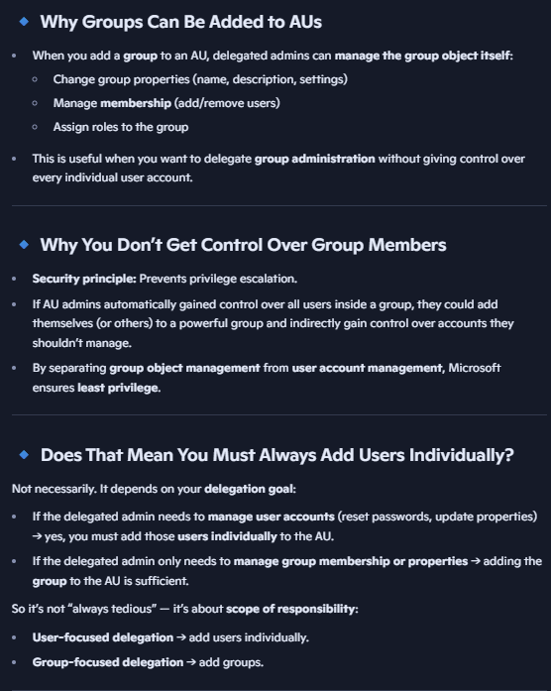
Important Functional Details
- Users vs Groups in AUs:
  - Adding a user to an AU gives the delegated admin control over that user’s account.
  - Adding a group to an AU grants control over the group object itself (e.g., managing group membership and properties), not over the users inside the group.
- Security Implication:
This separation prevents privilege escalation. If group members were automatically manageable through AU role assignment, an admin could add users to a group to gain control over those users’ accounts, which is a security risk.
- Example Scenario:
A delegated admin assigned User Administrator role for an AU can reset passwords for users explicitly added to that AU, but cannot reset passwords for users who are only members of groups added to the AU.

Features and Usage
- Management Interfaces:
  - Administrative Units can be managed via the Azure portal, PowerShell, REST API, and CSV bulk uploads.
  - Delegated admins can use the mystaff.microsoft.com portal for a streamlined user experience limited to their AU scope.
- Role Options:
Roles assignable at the AU level include:
  - Authentication Administrator
  - Groups Administrator
  - Help Desk Administrator
  - License Administrator
  - Password Administrator
  - User Administrator
- Granular Delegation Benefits:
  - Enables organizational units (departments, branches) to have localized management.
  - Reduces risk by limiting admin privileges to only the necessary scope.
  - Supports compliance and security best practices by minimizing over-broad permissions.

Key Insights
- Administrative Units provide a way to delegate Azure AD roles with scoped permissions, breaking the traditional tenant-wide role assignment model.
- Users can belong to multiple AUs, but AUs cannot be nested.
- Groups added to an AU only grant control over the group object, not the members, preventing privilege escalation.
- Delegated admins need Azure AD P1 license or higher, but managed users do not.
- The feature is currently in preview and applies only to regular Azure AD tenants, not Azure AD B2C.

